**NAME – KHUSHI PANWAR**

**ROLL NO – 2021334**

**JAVA PRACTICAL ASSIGNMENT : 07-04-2022**

1. **Write a basic Java program to print “Hello World”:**

**import** java.io.*;

**public** **class** HelloWorld{

**public** **static** **void** main(String[] args)**throws** IOException{

System.***out***.println("*****************\nHello World");

System.***out***.println("This is my first program in Java Language!");

}

}

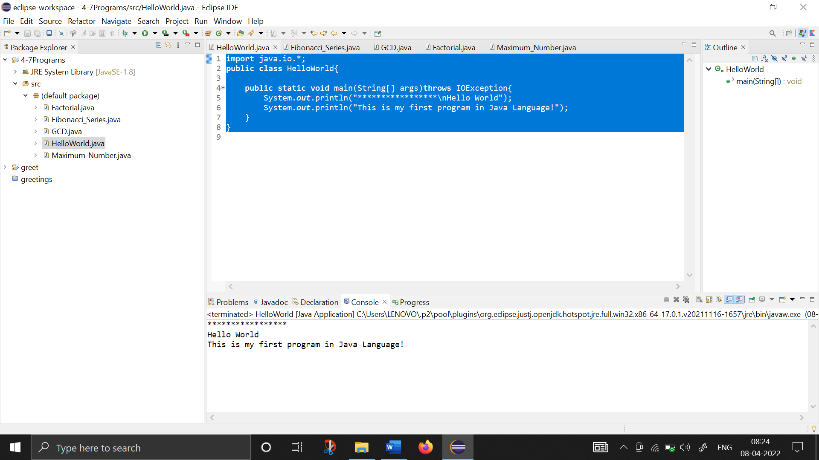

1. **Write a program to find the factorial of a number entered by the user:**

**import** java.io.*;

**public** **class** Factorial{

**public** **static** **void** main(String[] args)**throws** IOException{

System.***out***.println("*****************\nThis program calculates the factorial of a given number! \n*****************\n");

BufferedReader br1=**new** BufferedReader(**new** InputStreamReader(System.***in***));

**int** num;

System.***out***.println("Enter the number here: ");

num=Integer.*parseInt*(br1.readLine()); //used to convert entered input from string to integer

**int** factorial=1;

**for** (**int** i=1; i<=num; i++) {

factorial*=i;

}

System.***out***.println("Factorial of "+num+" is "+factorial);

}

}

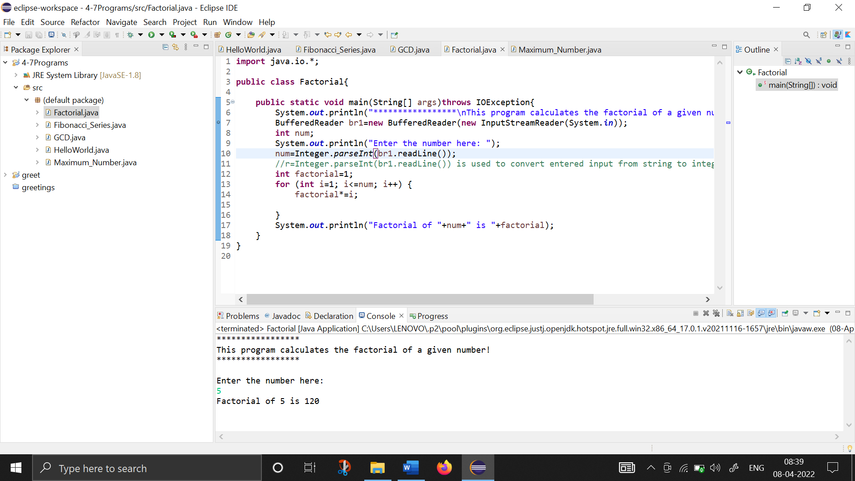

1. **Write a program to print Fibonacci Series:**

**import** java.io.*;

**public** **class** Fibonacci_Series{

**public** **static** **void** main(String[] args)**throws** IOException{

System.***out***.println("*****************\nThis program prints the Fibonacci Series from the number entered by user! \n*****************\n");

**int** a=1, b=1, c;

System.***out***.print("The Basic Fibonacci Series is as -> \n"+a+","+b);

**for** (**int** i=1; i<=10; i++) {

c=a+b;

System.***out***.print(","+c);

a++;

b++;

}

System.***out***.println("\n\n \t*USER DEFINED FIBONACCI SERIES* \n");

BufferedReader br1=**new** BufferedReader(**new** InputStreamReader(System.***in***));

**int** num1, num2, num3, terms;

System.***out***.println("How many terms do you want to print: ");

terms=Integer.*parseInt*(br1.readLine()); //used to convert entered input from string to integer

System.***out***.println("Enter the first number here: ");

num1=Integer.*parseInt*(br1.readLine()); //used to convert entered input from string to integer

System.***out***.println("Enter the second number here: ");

num2=Integer.*parseInt*(br1.readLine()); //used to convert entered input from string to integer

System.***out***.print("The Fibonacci Series is as -> \n"+num1+","+num2);

**for** (**int** i=1; i<=terms; i++) {

num3=num1+num2;

System.***out***.print(","+num3);

num1++;

num2++;

}

}

}

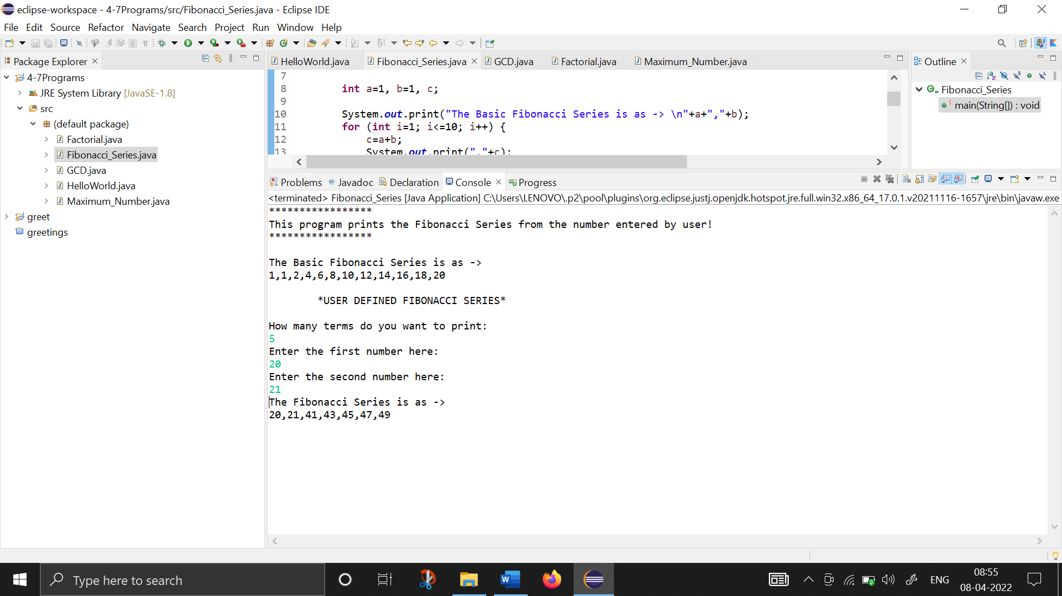

1. **Write a program to find the maximum number from the list of numbers entered by the user:**

**import** java.io.*;

**public** **class** Maximum_Number {

**public** **static** **void** main(String[] args)**throws** IOException{

BufferedReader br1 =**new** BufferedReader(**new** InputStreamReader(System.***in***));

System.***out***.println("**********\nThis program finds the MAXIMUM/GREATEST number from the given list of numbers!\n**********");

**int** term, num, max=0;

System.***out***.print("How many terms/numbers do you want to enter : ");

term=Integer.*parseInt*(br1.readLine());

**for** (**int** i=1; i<=term; i++) {

System.***out***.print("Enter the "+i+" term here : ");

num=Integer.*parseInt*(br1.readLine());

**if** (num>max)

max=num;

}

System.***out***.println("The Maximum/Greatest Number found is "+max);

}

}

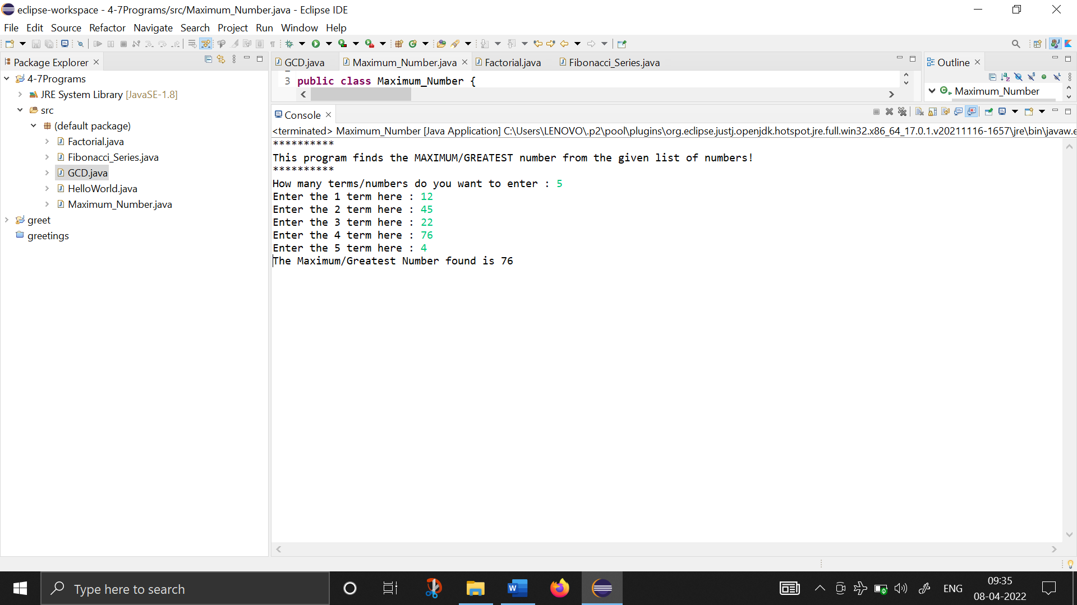

1. **Write a program to find GCD (Greatest Common Divisor) :**

**import** java.io.*;

**public** **class** GCD{

**public** **static** **void** main(String[] args)**throws** IOException{

System.***out***.println("*****************\nThis program calculates the Greatest Common Divisor of two numbers! \n*****************\n");

BufferedReader br1=**new** BufferedReader(**new** InputStreamReader(System.***in***));

**int** num1,num2,gcd=1;

System.***out***.println("Enter the first number here: ");

num1=Integer.*parseInt*(br1.readLine());

System.***out***.println("Enter the second number here : ");

num2=Integer.*parseInt*(br1.readLine());

**for** (**int** i=1; i<=num1 && i<=num2; i++) {

**if** (num1%i==0 && num2%i==0) {

gcd=i;

}

}

System.***out***.println("-> The Greatest Common Divisor of "+num1+" and "+num2+" is "+gcd);

}

}

